Evonik, the Optical Industry’s Reliable and Innovative Partner, Introduces TROGAMID® myCX
May 5, 2009

Dr. Ursula Keil
Marketing Support
Phone +49 2365 49-9878
Fax +49 2365 49-5992
ursula.keil@evonik.com

Essen, Germany-based Evonik Industries AG has expanded its TROGAMID® CX range to include the new TROGAMID® myCX, which it has put on the market—and right on time for the MIDO, too, the optics, optometry, and ophthalmology trade show held in Milan each year. TROGAMID® myCX stands for a new premium brand of microcrystalline high-performance polyamide and was improved specifically for the manufacture of sports glass and sunglass lenses. This new high-end material is a cut above the rest, thanks to its higher purity and optimized processing. Lenses can thus be more efficiently manufactured. Evonik also offers plastic films made of TROGAMID® myCX, which are clear as glass and suitable for laminating and decorating optical parts.

TROGAMID® myCX is permanently transparent, allowing a light transmission of 92 percent. Because of the low density and the high break- and scratch-resistance of the high-performance polyamide, sun glass lenses made of this material are not only exceptionally light, but very safe. The durability of TROGAMID® myCX in the face of aggressive agents has been significantly improved, compared to other transparent plastics, so the wearer does not have to think twice about using perfumes, sunscreens, and cleaning agents.

Many of these features are attributable to the polyamide’s microcrystalline structure. The crystallites, which are embedded in an amorphous environment, are so minute that they do not disperse visible light, and the material appears to be transparent to the human eye. Thus, the positive characteristics attributable to crystallinity, such as stress-cracking resistance, are retained without the material turning white. That is why TROGAMID® myCX combines the advantages of an amorphous polymer with those of a partially crystalline polymer, as no other transparent plastic can.

Lenses made of the high-performance polyamide can be drilled, ground, and milled, not to mention dyed any color. TROGAMID® myCX is particularly suitable for manufacturing gradient-index lenses. TROGAMID® myCX is available as a granulate and as a transparent, colorless film that is clear as glass and can be used for laminating and decorating optical parts. The films come in standard thicknesses of 125 and 400 micrometers. Other thicknesses can be provided upon request.

Figure caption:
Because of the low density and the high break- and scratch-resistance of TROGAMID® myCX, lenses made of this material are not only exceptionally light, but very safe.

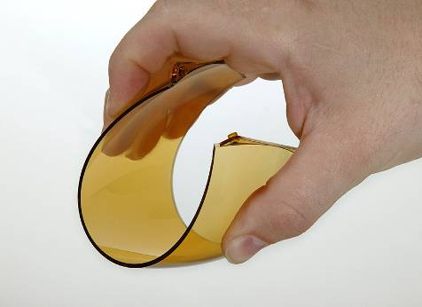

Company information
Evonik Industries is the creative industrial group from Germany which operates in three business areas: Chemicals, Energy and Real Estate. Evonik is a global leader in specialty chemicals, an expert in power generation from hard coal and renewable energies, and one of the largest private residential real estate companies in Germany. Our strengths are creativity, specialization, continuous self-renewal, and reliability. Evonik is active in over 100 countries around the world. In its fiscal year 2008 about 41,000 employees generated sales of about €15.9 billion and an operating profit (EBITDA) of about €2.2 billion.

Disclaimer
In so far as forecasts or expectations are expressed in this press release or where our statements concern the future, these forecasts, expectations or statements may involve known or unknown risks and uncertainties. Actual results or developments may vary, depending on changes in the operating environment. Neither Evonik Industries AG nor its group companies assume an obligation to update the forecasts, expectations or statements contained in this release.

