TROGAMID® surfaces look good and stay that way
March 17, 2010

Dr. Ursula Keil
Marketing Support
Phone +49 2365 49-9878
Fax +49 2365 49-809878
ursula.keil@evonik.com

Surfaces made of microcrystalline TROGAMID® are built tough. They stand up to sunlight, heat, shock, not to mention cosmetics and other chemicals. Essen, Germany-based Evonik Industries offers these high-quality top layers as TROGAMID® CX in granulate form for injection-molded applications and as TROGAMID® TCR films for surface lamination. The films are available in thicknesses ranging from 50 µm to 750 µm for surface decoration and surface protection.

Durable products such as cars, lavishly decorated panels, consoles, and operational controls have to retain their appearance over the entire useful life of the vehicle. Touching these surfaces often exposes them to the destructive effects of sweat, skin oil, and cosmetics. But even cleaning agents can damage them. Frequent temperature swings, such as when a vehicle stands under the scorching sun after a cool night, take their toll, too. All of these conditions increase the likelihood of stress cracking and clouding on the surface, which prompt customer complaints and are damaging to a company’s image.

Surfaces made of microcrystalline TROGAMID® are the solution. With far greater chemical resistance than other transparent plastics, this transparent polyamide is particularly resistant to suntan lotions and cosmetics. In accordance with VW test specifications, a study comparing the effects of hand and suntan lotions was conducted and confirmed these properties. In the test, TROGAMID® films were in contact with the lotions at a temperature of 80°C for 24 hours. A material passes the test when treatment does not change it noticeably and its scratch resistance remains the same as before. Only the 50 µm specialty polyamide film passed the test in all points. Styrene acrylonitrile (SAN), scratch-resistant polymethyl methacrylate (PMMA), and polycarbonate (PC) were tested for comparison.

The crystal-clear, colorless optics of TROGAMID® films or injection-molded coatings also allow maximum freedom in surface design and cause no color shift on back-printed designs. Resistant to weather and UV light, these top layers are non-abrasive and impart an attractive relief effect. Their scratch resistance is similar to that of PMMA.
Caption: The chemical resistance of TROGAMID® is far superior to that of other transparent plastics—particularly with regard to suntan lotions and cosmetics.

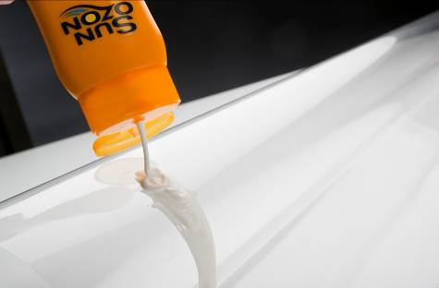

Caption: TROGAMID® results in high-quality surfaces that show no signs of daily abuse.

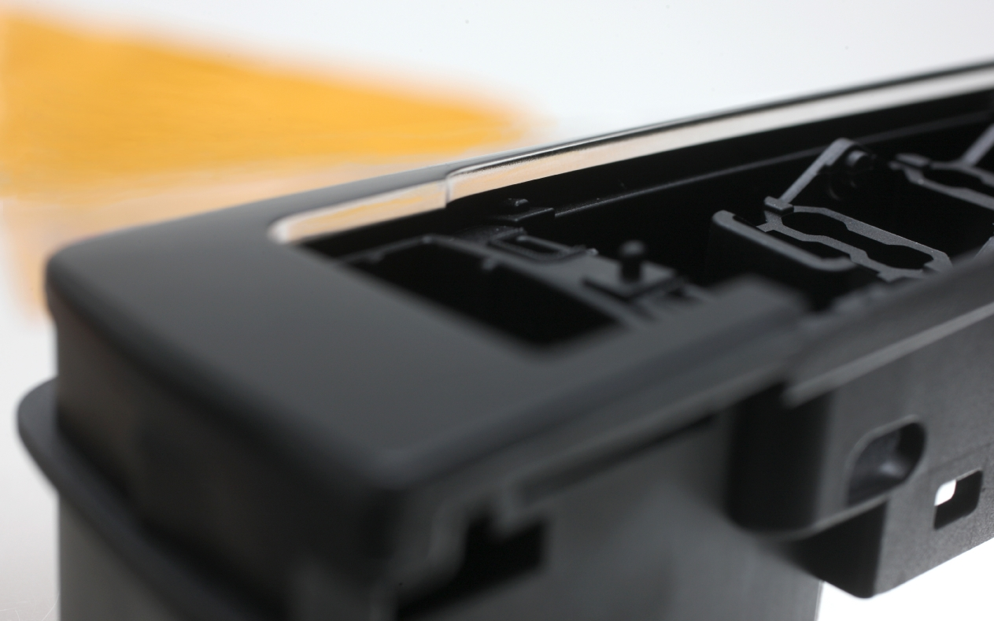

Company information
Evonik Industries is the creative industrial group from Germany which operates in three business areas: Chemicals, Energy and Real Estate. Evonik is a global leader in specialty chemicals, an expert in power generation from hard coal and renewable energies, and one of the largest private residential real estate companies in Germany. Our strengths are creativity, specialization, continuous self-renewal, and reliability. Evonik is active in over 100 countries around the world. In its fiscal year 2008 about 41,000 employees generated sales of about €15.9 billion and an operating profit (EBITDA) of about €2.2 billion.

Disclaimer

In so far as forecasts or expectations are expressed in this press release or where our statements concern the future, these forecasts, expectations or statements may involve known or unknown risks and uncertainties. Actual results or developments may vary, depending on changes in the operating environment. Neither Evonik Industries AG nor its group companies assume an obligation to update the forecasts, expectations or statements contained in this release.

