Protecting High-Quality Surfaces
October 27, 2010

Dr. Ursula Keil
Marketing Support High Performance Polymers
Phone +49 2365 49-9878
Fax +49 2365 49-809878
ursula.keil@evonik.com

- Suntan lotion-resistant surface decoration thanks to in-mold laminated TROGAMID® TCR films
- Evonik Industries, Pröll, and Niebling showcase film, color, and manufacturing process.

Surfaces made of TROGAMID® TCR microcrystalline polyamide films (Transparent, Chemical Resistant) are built tough. They stand up to sunlight, heat, and shock, not to mention cosmetics such as suntan lotion and other chemicals. Whether transparent or printed, they also have a luxurious look. Essen, Germany-based Evonik Industries supplies TROGAMID® TCR films in thicknesses ranging from 50 µm to 750 µm for decorating and protecting high-quality surfaces.

Durable products such as cars, lavishly decorated panels, consoles, and operational controls have to retain their appearance over the entire useful life of the vehicle. Touching these surfaces often exposes them to the detrimental effects of sweat, skin oil, and cosmetics. But even cleaning agents can damage them. Frequent temperature swings, such as when a vehicle stands under the scorching sun after a cool night, take their toll, too. All of these conditions increase the likelihood of stress cracking and clouding on the surface, which prompt customer complaints and are damaging to a company’s image.

Transparent TROGAMID® TCR films offer a remedy. Manufactured from colorless microcrystalline polyamide, and with far greater chemical resistance than other transparent plastics, these films are particularly resistant to suntan lotions and cosmetics. In accordance with VW test specifications, a study comparing the effects of hand and suntan lotions was conducted and confirmed these properties. In the test, TROGAMID® TCR films were in contact with the lotions at a temperature of 80°C for 24 hours. A material passes the test when treatment does not change it noticeably and its scratch resistance remains the same as before. Only the 50 µm specialty polyamide film passed the test in all points. Styrene acrylonitrile (SAN), polymethyl methacrylate (PMMA), and polycarbonate (PC) were tested for comparison.

Crystal-clear and colorless, TROGAMID® TCR films give designers maximum freedom in surface design and cause no color shift on back-printed designs. Resistant to weather and UV light, these top layers are non-abrasive and impart an attractive relief effect. Their scratch resistance is similar to that of uncoated films complying with the industry standard.

This brings us to the color version: We have developed printing inks and a process for in-mold laminating TROGAMID® TCR films in conjunction with Pröll KG (Weissenburg, Germany), a producer of industrial screen printing inks, and tool manufacturer Niebling Junior (Penzberg, Germany). NoriAmid, Pröll’s new printing ink system, the processing of the film, and the initial components will be presented to the public for the first time during the K’2010.

Captions:

The chemical resistance of TROGAMID® TCR films is far superior to that of other transparent plastics—particularly with regard to suntan lotion and other cosmetics.

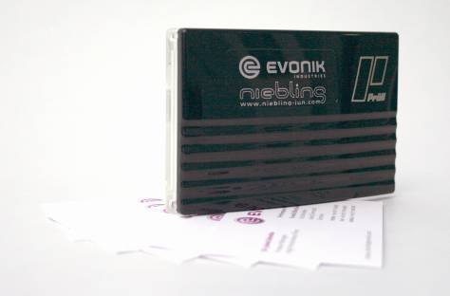
Printing inks and an in-mold lamination process were specially developed for TROGAMID® TCR films.

Exceptional solutions in plastics are no exception for us
Working together with its customers and partners, Evonik develops products and system solutions for and with plastics. We thus have a range of services that satisfies market and application requirements.

Evonik is present in all major growth markets around the globe. Its customized products and solutions include raw materials, sophisticated additives and paints, engineering plastics, high-performance polymers, and semi-finished products. They are virtually exactly what is needed for tomorrow’s efficient, sustainable, and environmentally friendly ideas.

About Evonik
Evonik Industries is the creative industrial group from Germany. In our core business of specialty chemicals, we are a global leader. In addition, Evonik is an expert in power generation from hard coal and renewable energies, and one of the largest private residential real estate companies in Germany. Our company’s performance is shaped by creativity, specialization, continuous self-renewal, and reliability.

Evonik is active in over 100 countries around the world. In its fiscal year 2009 about 39,000 employees generated sales of about €13.1 billion and an operating profit (EBITDA) of about €2.0 billion.

Disclaimer
In so far as forecasts or expectations are expressed in this press release or where our statements concern the future, these forecasts, expectations or statements may involve known or unknown risks and uncertainties. Actual results or developments may vary, depending on changes in the operating environment. Neither Evonik Industries AG nor its group companies assume an obligation to update the forecasts, expectations or statements contained in this release.

