K 2013, Hall 6 Booth No. B28
October 17, 2013
Contact person specialized press
Ursula Keil
High Performance Polymers
Phone +49 2365-49-9878
Fax +49 2365-49-809878
ursula.keil@evonik.com

Evonik Industries AG
Rellinghauser Straße 1-11
45128 Essen
Germany
Phone +49 201 177-01
Telefax +49 201 177-3475
www.evonik.de

Supervisory Board
Dr. Werner Müller, Chairman
Executive Board
Dr. Klaus Engel, Chairman
Dr. Thomas Haeberle,
Thomas Wessel, Patrik Wohlhauser, Ute Wolf, Dr. Dahai Yu

Registered office Essen
Registered court
Essen local court
Commercial registry B 19474
VAT ID no. DE 811160003

New transparent polyamide grade allows for steam sterilization, closing the gap with polysulfone

Essen, Germany-based Evonik Industries has developed a highly transparent polyamide on the basis of innovative monomers that can withstand higher temperatures. TROGAMID® RS6121 (development name) allows for steam sterilization at 134 °C and a pressure of 2 bar.

Transparent polyamides form a special group among semi-crystalline polyamides. Their uses place the highest demands on polymeric properties. Combined success factors for industrial use and application in medical technology and optics include resistance to chemicals, static and dynamic durability and abrasion resistance. The material's inadequate temperature resistance, however, used to present an obstacle for a number of application areas. The newly developed polyamide TROGAMID® RS6121 significantly improves the performance of the TROGAMID® CX product family. It allows for applications that used to be reserved for other polymers such as polysulfones because of temperature resistance requirements.

The highly transparent TROGAMID® CX polyamides are plastics made of asymmetrical polymer components that reduce the customary crystalline polyamide morphology or form micro-crystalline structures that have no influence on transparency. TROGAMID® RS6121 was developed on the basis of innovative monomers. Just as the other proven products, it is highly transparent. In addition to the known basic properties of the TROGAMID® CX family such as excellent resistance to chemicals, high static and dynamic durability as well as abrasion resistance, high impact resistance, good weather resistance and scratch resistance, this grade has a few additional characteristics that make it especially suited for applications with higher temperature requirements.

Thus, the (dry) glass transition temperature of TROGAMID® RS6121 is approx. 30° C higher than in TROGAMID® CX7323, which ultimately results in a higher maximum continuous use temperature. Thanks to the significantly reduced water absorption of below two percent, the glass transition temperature does not fall below 134 °C, even when saturated. Components made of TROGAMID® RS6121 can therefore be steam-sterilized at 134 °C and 2 bar without any impact on mechanical properties. Alternative sterilization methods rely on gamma radiation or ethylene oxide. Additionally, TROGAMID® RS6121 is approx. 20% less dense than, for example, PSU. The combination of these properties opens up a multitude of new application fields for the new product in medical technology, the electrical industry, as well as automotive and mechanical engineering.

Caption:
Thanks to the significantly reduced water absorption of less than 2 percent, components made of TROGAMID® RS6121 can be steam-sterilized at 134 °C and 2 bar without any impact on mechanical properties.

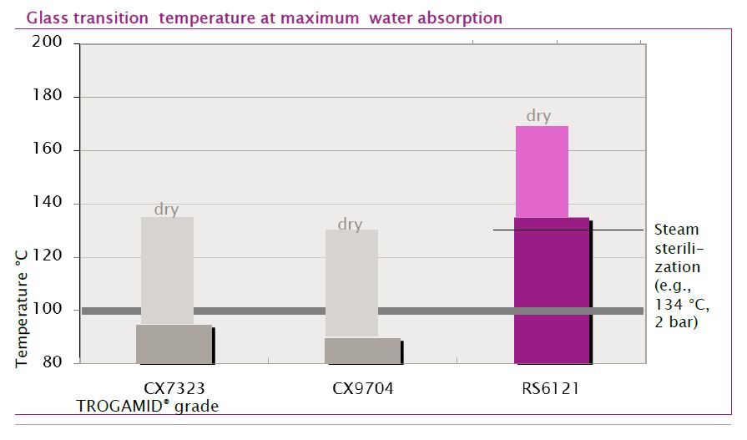

Company information
Evonik, the creative industrial group from Germany, is one of the world leaders
in specialty chemicals. Profitable growth and a sustained increase in the value of the company form the heart of Evonik’s corporate strategy. Its activities focus on the key megatrends health, nutrition, resource efficiency and globalization. Evonik benefits specifically from its innovative prowess and integrated technology platforms.

Evonik is active in over 100 countries around the world. In fiscal 2012 more than 33,000 employees generated sales of around €13.4 billion and an operating profit (adjusted EBITDA) of about €2.4 billion (excluding Real Estate in both cases).

Disclaimer
In so far as forecasts or expectations are expressed in this press release or where our statements concern the future, these forecasts, expectations or statements may involve known or unknown risks and uncertainties. Actual results or developments may vary, depending on changes in the operating environment. Neither Evonik Industries AG nor its group companies assume an obligation to update the forecasts, expectations or statements contained in this release.

