January17, 2017

Contact specialized press
Janusz Berger
Communication Manager
High Performance Polymers
Phone +49 2365 49-9227
janusz.berger@evonik.com

Evonik Resource Efficiency GmbH
Rellinghauser Straße 1-11
45128 Essen
Phone +49 201 177-01
Fax +49 201 177-3475
www.evonik.com

Supervisory Board
Dr. Ralph Sven Kaufmann, Chairman

Executive Board
Dr. Claus Rettig, Chairman
Dr. Johannes Ohmer,
Simone Hildmann,
Alexandra Schwarz

Registered Office: Essen
Register Court: Essen Local Court
Commercial Registry B 25783
VAT ID no. DE 815528487

MIDO 2017: Evonik presents TROGAMID® for more freedom of design in optical applications

Evonik will be at this year’s MIDO in Milan, Italy, presenting an innovative technology for manufacturing eyeglasses frames: IMPLEX is based on TROGAMID®, a transparent, high-performance plastic, and gives eyewear manufacturers more freedom of design.

Unlike traditional production methods, this novel technology involves cutting the finished frames from a single, curved preform, thus omitting the machining and finishing steps after injection molding. The preform is made ahead of time from multiple functional layers—the base frame made of TROGAMID®, the adhesive and coating layers, or the scratch-resistant film—and can be produced relatively quickly and flexibly, varying both the size of the preform and its radius of curvature.

Design variety with TROGAMID®
IMPLEX wins customers over with easy handling, excellent productivity, and the ability to customize in a variety of colors, textures, and patterns. For eyewear manufacturers, the ability to implement designs even more quickly is a major advantage of the innovative technology.

The innovation meets customer demands through its use of two material solutions from Evonik: TROGAMID® CX9704 is a transparent polyamide used for the base frame—its pliability allows manufacturers to vary the shape of the product. The second structural layer, which is made with TROGAMID® CX9711, has excellent processing characteristics and is highly resistant to chemicals.

Cooperation between Evonik and Tungfung
The development of IMPLEX is based on decades of materials experience that Evonik has amassed in the field of high-performance plastics, along with technical expertise in the optics industry provided by Tungfung, a professional eyewear producer headquartered in Hong Kong. Evonik offers the right material and product expertise, while Tungfung serves as an expert partner in the production of exceptional eyeglasses frames.
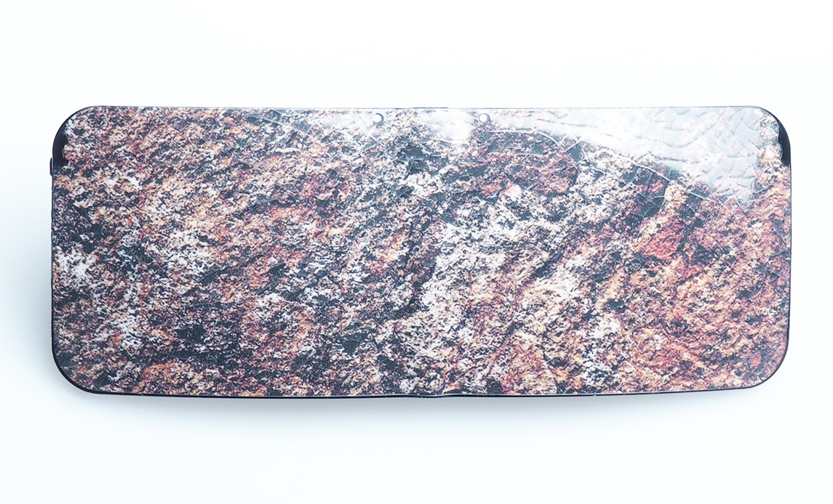
Caption: IMPLEX preform based on TROGAMID®.
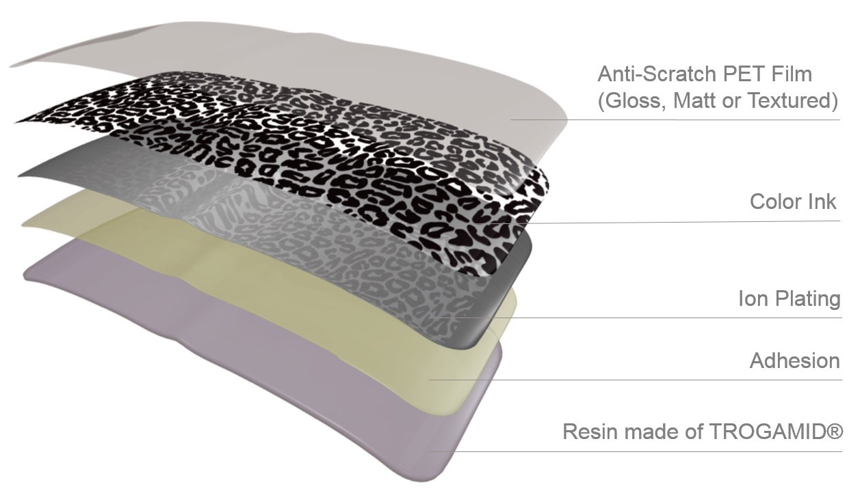
Caption: The IMPLEX preform is made ahead of time from multiple functional layers.
Learn more about high-performance plastic TROGAMID® for optical applications at our booth (G61, Hall 2) at MIDO, February 25 – 27, in Milan, Italy.

Follow us on Twitter, LinkedIn, Facebook and Google+

About Tungfung
Tungfung, the Group is the leading "one-stop" spectacles related raw materials and components supplier with the largest product range in Hong Kong. The Group offers one-stop production solution from procurement and manufacture of spectacles related raw materials and components to provision of after-sales services to its customers.

Company information
Evonik, the creative industrial group from Germany, is one of the world leaders in specialty chemicals, operating in the Nutrition & Care, Resource Efficiency and Performance Materials segments. The company benefits from its innovative prowess and integrated technology platforms. In 2015 more than 33,500 employees generated sales of around €13.5 billion and an operating profit (adjusted EBITDA) of about €2.47 billion.

About Resource Efficiency
The Resource Efficiency segment is led by Evonik Resource Efficiency GmbH and supplies high performance materials for environmentally friendly as well as energy-efficient systems to the automotive, paints & coatings, adhesives, construction, and many other industries. This segment employed about 8,600 employees, and generated sales of around €4.3 billion in 2015.

Disclaimer
In so far as forecasts or expectations are expressed in this press release or where our statements concern the future, these forecasts, expectations or statements may involve known or unknown risks and uncertainties. Actual results or developments may vary, depending on changes in the operating environment. Neither Evonik Industries AG nor its group companies assume an obligation to update the forecasts, expectations or statements contained in this release.

