February 08, 2017

Contact specialized press
Janusz Berger
Communication Manager
High Performance Polymers
Phone +49 2365 49-9227
janusz.berger@evonik.com

Evonik Resource Efficiency GmbH
Rellinghauser Straße 1-11
45128 Essen
Phone +49 201 177-01
Fax +49 201 177-3475
www.evonik.com

Supervisory Board
Dr. Ralph Sven Kaufmann, Chairman

Executive Board
Dr. Claus Rettig, Chairman
Dr. Johannes Ohmer,
Simone Hildmann,
Alexandra Schwarz

Registered Office: Essen
Register Court: Essen Local Court
Commercial Registry B 25783
VAT ID no. DE 815528487

Enjoy sports: A frame revolution for sport glasses with transparent polyamide TROGAMID® by Evonik

At MIDO 2017 in Milan Italy, Evonik will demonstrate its new application for the sport glasses’ frame manufactured with TROGAMID®, a kind of high performance plastic with excellent transparency properties. TROGAMID® is considered to be the ideal replacement for already established materials by means of its improved wearing experience and enduring style.

Fashion but more wear comfort with TROGAMID®

Suitable sport equipment not only symbolizes the fashion but also brings comfort and convenience to the consumers. Sport enthusiasts are always looking for the lighter sport equipment.

Characterized with its lightweight construction, TROGAMID® CX9704 makes the sport glasses’ frame lighter than other materials. Therefore, the wearing experience will be significantly improved. Meanwhile, the advantages of TROGAMID®’s outstanding transparency as well as the easy processing and coloring give the freedom in design and guarantee the fabulous appearance.

Enduring and unbreakable to enjoy sports
Sand, dust, creams or sweat–sunglasses are exposed to a lot. Low temperature and tough weather condition will also influence the frame’s enduring performance. Manufactures were obsessed with these unsolved problems in the past. However, thanks to the excellent chemical resistance, TROGAMID®-based sport glasses frame is free from sun cream’s damage and assured with longer product cycle. In addition, TROGAMID®’s remarkable weathering resistance under extreme condition also offers the glasses more ductility but strong and enduring performance even under the extreme weather.

Cooperation between Evonik and JAAN LIH Optical
The success of this innovative application is built on the cooperation between Evonik and JAAN LIH Optical Co.,Ltd. As a pioneer in the lens and eyewear industry in Taiwan, JAAN LIH is specialized for manufacturing sports eyewear, sunglasses, high quality lenses and personal protective equipments. Evonik supplies the TROGAMID® material and provides the technical expertise to support JAAN LIH in developing such application while JAAN LIH, as a strategic partner, has made efforts to create better sport glasses wearing experience for the sports fans.

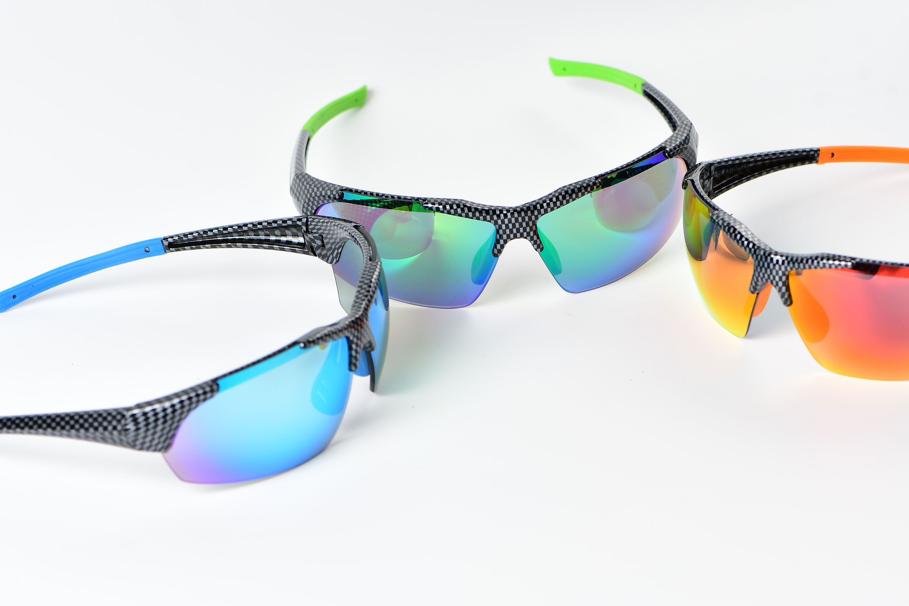

Caption: A frame revolution for sport glasses with transparent polyamide TROGAMID® by Evonik
Learn more about high-performance plastic TROGAMID® for optical applications at our booth (G61, Hall 2) at MIDO, February 25 – 27, in Milan, Italy.

Follow us on Twitter, LinkedIn, Facebook and Google+

For further information, visit www.trogamid.com

Company information
Evonik, the creative industrial group from Germany, is one of the world leaders in specialty chemicals, operating in the Nutrition & Care, Resource Efficiency and Performance Materials segments. The company benefits from its innovative prowess and integrated technology platforms. In 2015 more than 33,500 employees generated sales of around €13.5 billion and an operating profit (adjusted EBITDA) of about €2.47 billion.

About Resource Efficiency
The Resource Efficiency segment is led by Evonik Resource Efficiency GmbH and supplies high performance materials for environmentally friendly as well as energy-efficient systems to the automotive, paints & coatings, adhesives, construction, and many other industries. This segment employed about 8,600 employees, and generated sales of around €4.3 billion in 2015.

Disclaimer
In so far as forecasts or expectations are expressed in this press release or where our statements concern the future, these forecasts, expectations or statements may involve known or unknown risks and uncertainties. Actual results or developments may vary, depending on changes in the operating environment. Neither Evonik Industries AG nor its group companies assume an obligation to update the forecasts, expectations or statements contained in this release.

