January 15, 2019

Specialized Press Contact
Janusz Berger
Communication Manager
High Performance Polymers
Phone +49 2365 49-9227
janusz.berger@evonik.com

Evonik Resource Efficiency GmbH
Rellinghauser Straße 1-11
45128 Essen
Phone +49 201 177-01
Fax +49 201 177-3475
www.evonik.com

Supervisory Board
Dr. Harald Schwager, Chairman
Managing Directors
Dr. Claus Rettig, Chairman
Dr. Johannes Ohmer
Simone Hildmann
Alexandra Schwarz

Registered Office: Essen
Register Court: Essen Local Court
Commercial Registry B 25783
VAT ID no. DE 815528487

MIDO 2019: Evonik introduces new TROGAMID® molding compound for optical applications

Evonik has developed a new polyamide molding compound for optical applications. TROGAMID® myCX high flow offers crystal-clear transparency, excellent wear comfort and high durability along with improved processing capabilities. This unique property profile makes the high-performance polymer a preferred material for high-end lenses and visors, e.g. in sun visors or ski goggles. The specialty chemicals company will present TROGAMID® myCX high flow at MIDO 2019 in Milan (Italy) from February 23 to 25.

Improved material processing for greater efficiency

Compared to similar high-performance materials, the significantly improved flowability of TROGAMID® myCX makes it possible to process the molding compound at a temperature profile that is at least 20°C lower. That enables greater energy efficiency and productivity in processing.

TROGAMID® myCX high flow, which stands out for its excellent transparency of over 90% and low density of 1.03 g/cm², was specifically designed for demanding optical applications such as premium lenses or high-end visors for ski and snowboard goggles. The high-performance polymer combines outstanding quality and freedom of design with maximum wear comfort. Due to its exceptional mechanical properties, resistance to stress cracking, and breaking strength, TROGAMID® myCX high flow guarantees the high levels of durability and safety that are essential for the optical industry. In addition, the new transparent polyamide by Evonik can be combined with all frame materials.

Tailor-made plastic materials
TROGAMID® stands for a product family of transparent polyamides that have been used in the optical industry with great success for over 20 years. The portfolio includes innovative high-performance polymers for lenses and frames as well as further materials, including for UV protection or polarizing films for high-contrast vision.
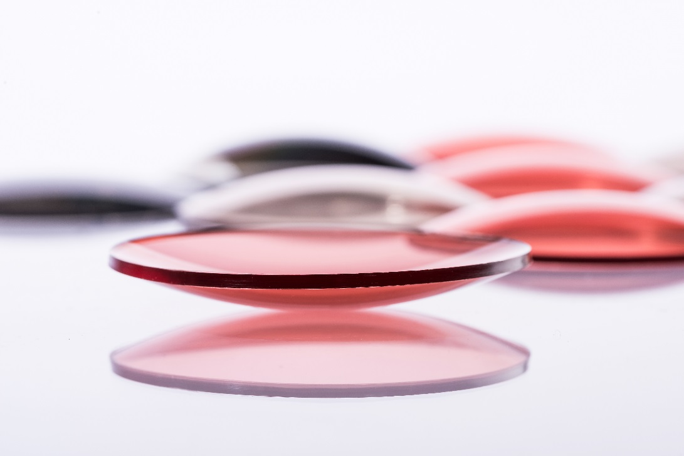
Caption: Evonik introduces TROGAMID® myCX high flow, a new transparent polyamide for demanding optical applications such as premium lenses or high-end visors for ski and snowboard goggles.

To learn more about the TROGAMID® high-performance polymer for the optical industry, visit our stand H05 in Hall 6 at MIDO from February 23 to 25 in Milan, Italy.

About Evonik
Evonik is one of the world leaders in specialty chemicals. The focus on more specialty businesses, customer-orientated innovative prowess and a trustful and performance-oriented corporate culture form the heart of Evonik’s corporate strategy. They are the lever for profitable growth and a sustained increase in the value of the company. Evonik benefits specifically from its customer proximity and leading market positions. Evonik is active in over 100 countries around the world with more than 36,000 employees. In fiscal 2017, the enterprise generated sales of €14.4 billion and an operating profit (adjusted EBITDA) of €2.36 billion.

About Resource Efficiency
The Resource Efficiency segment is led by Evonik Resource Efficiency GmbH and produces high performance materials and specialty additives for environmentally friendly as well as energy-efficient systems to the automotive, paints & coatings, adhesives, construction, and many other industries. This segment employed about 10,000 employees, and generated sales of around €5.4 billion in 2017.

Disclaimer
In so far as forecasts or expectations are expressed in this press release or where our statements concern the future, these forecasts, expectations or statements may involve known or unknown risks and uncertainties. Actual results or developments may vary, depending on changes in the operating environment. Neither Evonik Industries AG nor its group companies assume an obligation to update the forecasts, expectations or statements contained in this release.

